Welcome to our newsletter, providing updates within the surgery and information on services that we hope you will find useful.

Have your say in what we publish by sending your suggestions to: priory.view@nhs.net

If you would like a copy of the newsletter emailing to you each quarter, please contact reception.

Here for you
Due to the pandemic the way we work has changed and most appointments offered will be by telephone or video consultation. Whilst we can’t currently offer walk-in appointments if you do need to see a GP then please call to book an appointment and the GP will assess if you need to be seen face to face.

Flu Clinics
This year our annual flu clinics will be running at Priory View every Tuesday morning and Thursday afternoon from Tuesday 22nd September through until the end of October. Invitations will be sent to our over 65’s and patients eligible for a flu vaccination. Public Health England have indicated that another group of patients aged 50 – 64 may also be eligible during the 2020 flu campaign and we are waiting to hear how this will be given. It is likely that this additional group of patients will be vaccinated during November / December 2020 depending on the current supplies of flu vaccination. We will contact all eligible patients in due course.

Covid-19 update
Thank you to all our patients for your continued support and cooperation when coming in to the surgery. We hope you have found the seat numbers helpful when waiting and by coming on-time for your appointment we should be able to keep cross-over of people in our waiting areas to a minimum.

The health and safety of all our patients and staff is at the heart of everything we do and by keeping-up with regular touch-point cleaning around the surgery and providing masks for all patients and visitors upon arrival we are confident that we can keep everyone as safe as possible during the on-going pandemic.

Covid-19 patient support –Throughout April and June, our Social Prescribing team joined forces with volunteers to call patients who received the Government Shielding Letter. The team helped patients refer into the NHS Volunteers scheme for help with shopping and prescription pick-ups and shared numbers for local butchers and green grocers who were offering home deliveries.

If you, or someone you know, would like to register for support from the NHS Volunteers then please call 0808 196 3646 (8am-8pm 7 days a week)

Supporting Care Homes
At the start of the pandemic Priory View and Armley Primary Care Network quickly recognised the need to support our vulnerable care home patients. We did this by sharing PPE and making sure patients were regularly visited by Sarah and Vanya, our two Heath Care Assistants who work across the Primary Care Network.

Fortunately Covid-19 cases in our local care homes have been low and our Care Home Team continue working hard to make sure our vulnerable patients are being well cared for and are safe.

The Primary Care Network recently employed a Nurse, Charlotte, to join the Care Homes Team to build on recent good works and each care home has been aligned to a GP practice.

Priory View will take all new patients at Hillcrest and Rievaulx House care homes.

The Better Health Campaign
Launched this summer (you may have seen the colourful posters on billboards/bus shelters and around our surgery) and is all about helping people to eat better and get active. Now more than ever it is really important to try and maintain a healthy body weight, which in turn makes it easier for your body to fight diseases like cancer, heart disease and now Covid-19. There’s a wealth of tools and support available (including a free Weight Loss Plan app) at nhs.uk/Better Health.

Surgery improvements
This Autumn our surgery will be undergoing a bit of a ‘makeover’ and much-needed lick of paint on the outside of the building. We’ll also be replacing the wooden windows in the consulting rooms on the first floor with new PVC windows as well as removing the metal grills currently up around the outside of the building. Hopefully by the end of the year our surgery will be looking a lot brighter and more welcoming from the outside.

Priory View Team News
Congratulations to Dr Cheung who left for maternity leave in August. Dr Matthews will be covering Dr Cheung’s surgeries whilst she is away.

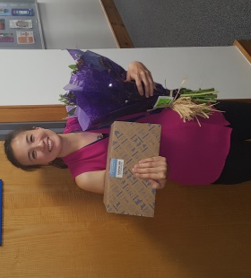

We are pleased to welcome four new Registrars to our surgery; Dr Amorginos, Dr Till, Dr Dewedi and Dr Idehen, who will all be with us until early next year.

And finally, this September sees Yvette Micklethwaite mark her 20th anniversary working at Priory View. There isn’t anything about Priory View that Yvette doesn’t know and patients and GPs would be lost without her exceptional knowledge on the complex referral process – here’s hoping she stays for another 20 years!
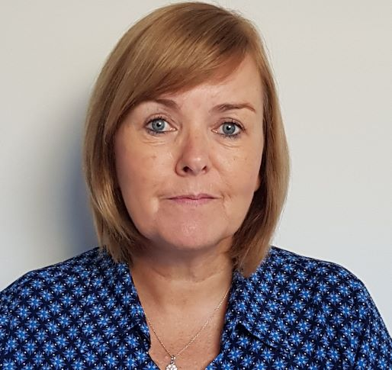

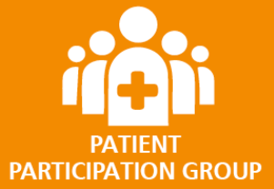
We run a patient participation group (PPG) and we are looking for people to help us improve the experience of our patients.
You don’t need any special skills or experience; you just need to be passionate about great quality healthcare.
To register your interest, please contact our practice by phone and speak to one of our Reception team.
Opening Times
Priory View
Monday 0700 – 1800
Tuesday 0730 – 1800
Wednesday 0800 – 1800
Thursday 0730 – 1800
Friday 0800 – 1800
Armley Hub @ Priory
Mon – Fri (am) 0700 – 0800
Mon – Fri (pm)
Telephone Only 1800 – 1900
Saturday 0800 – 1400
Sunday 0800 – 1200

Training Days
Priory View will be closed from 12pm on the third Thursday of every month to provide time for staff and GPs to undertake compulsory training.
The surgery will closed from 12.30pm on:

Thursday 24th September
Thursday 22nd October
Thursday 26th November

